Note: In this case I have created a business partner number ZRT_ABC.

Participants may create any business partner number

1. Go to SM35. Click on the Recording button.

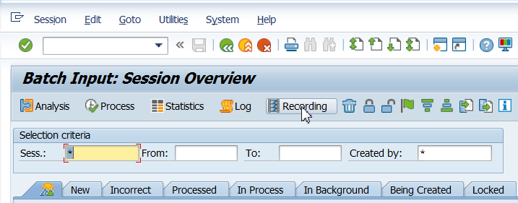

1. Click on New Recording.

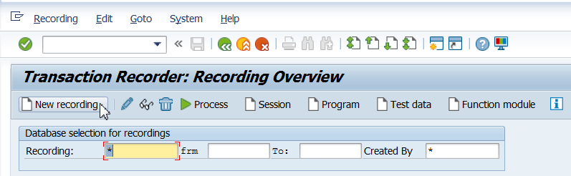

1. Enter details as shown below and click Start recording

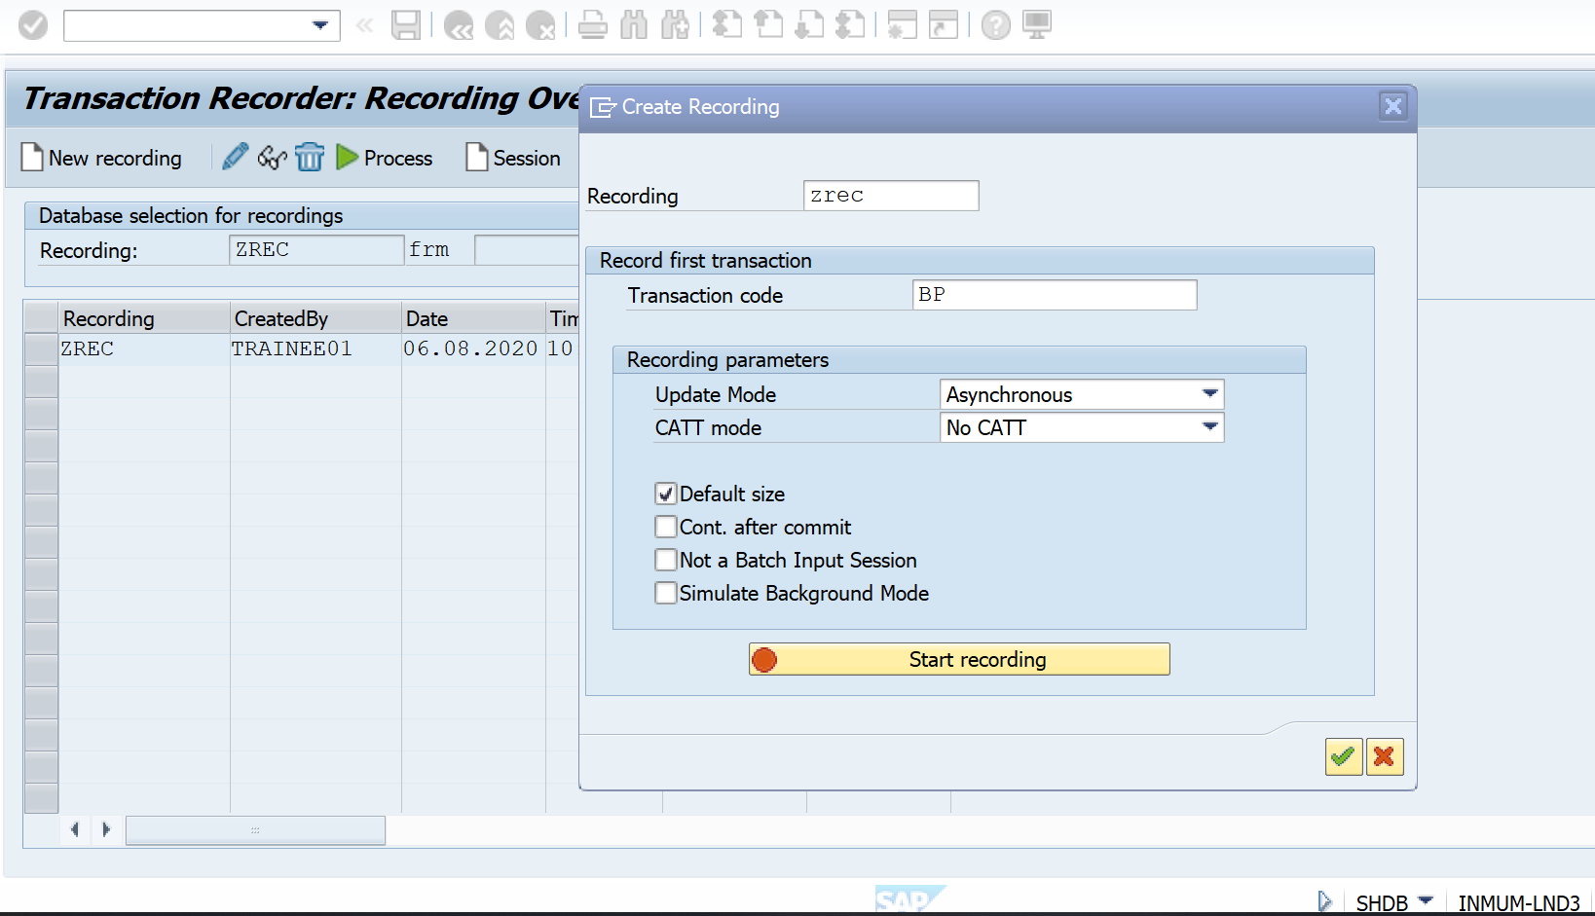

1. Click on Person in the below screen

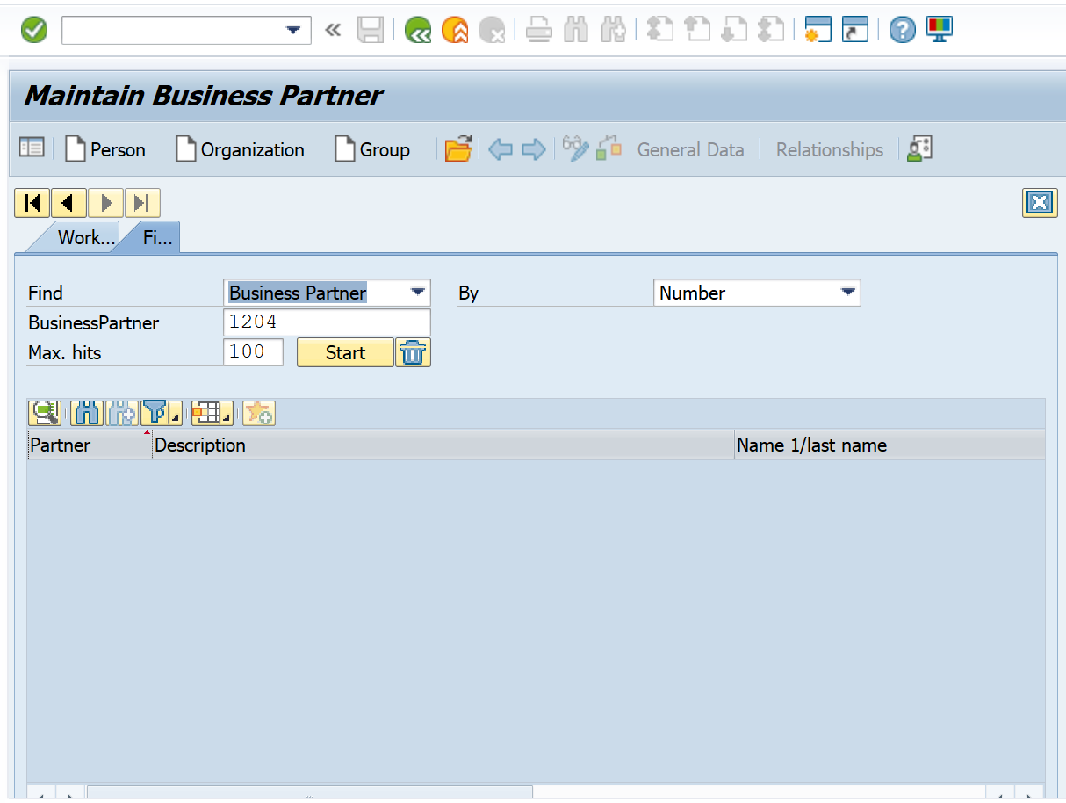

Fill the details .Give unique Buisness Partner Number (Eg. ZRT_ABC)

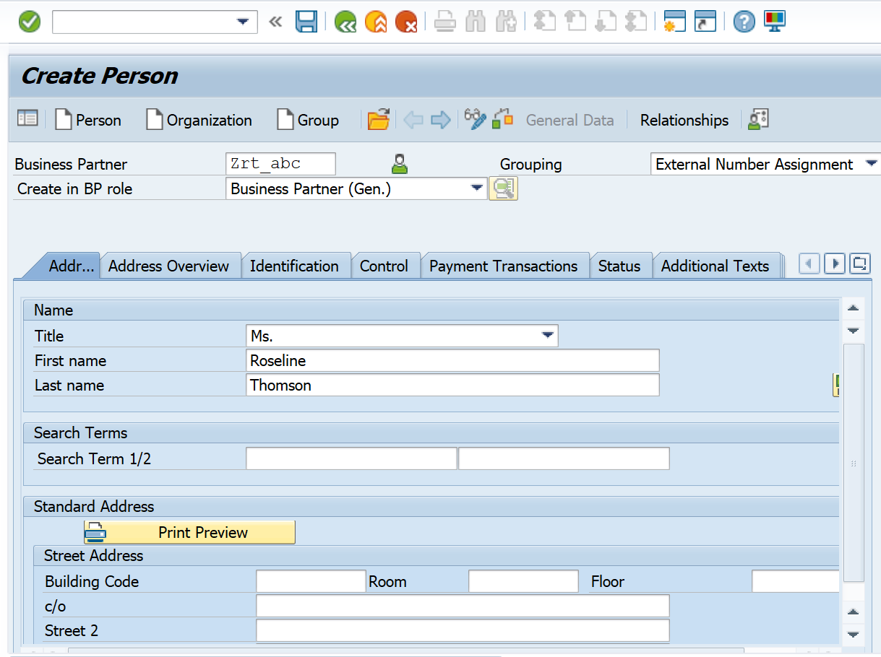

Scroll down and fill more details. Then **Click on Save**

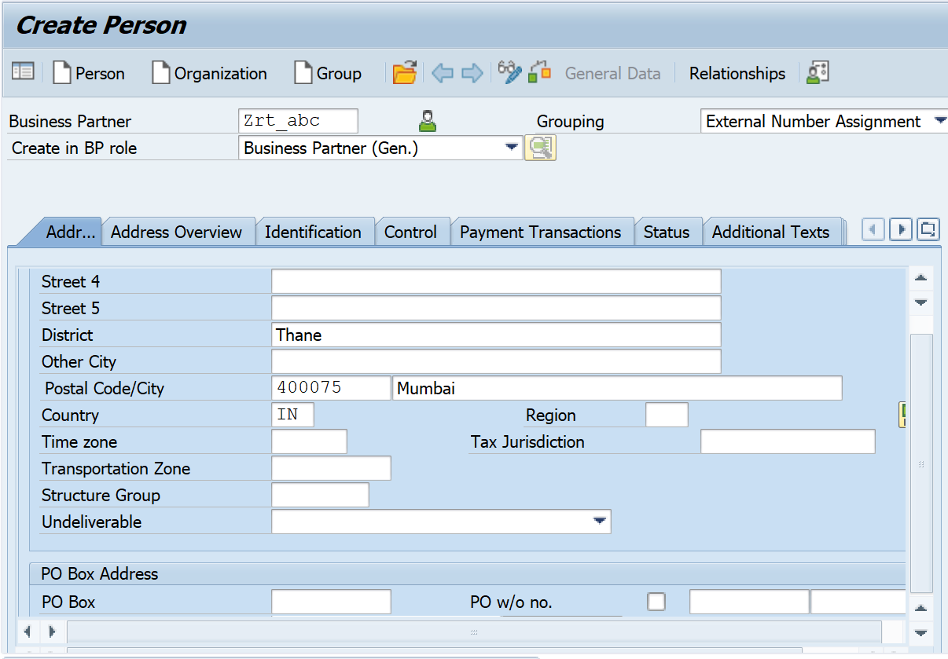

Recording is created .Click Save on below screen.then Go back

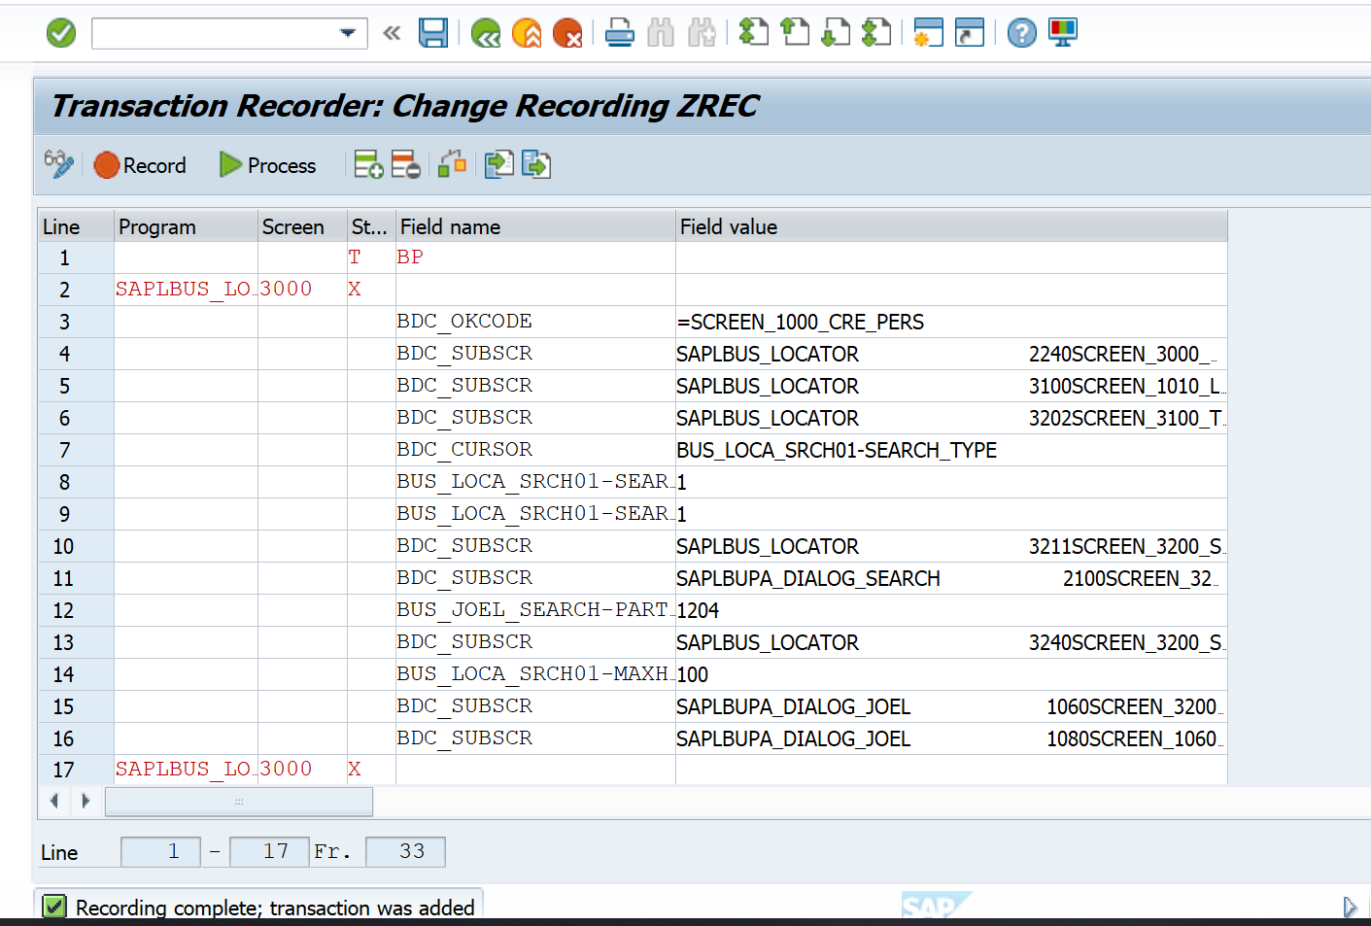

Click on program.

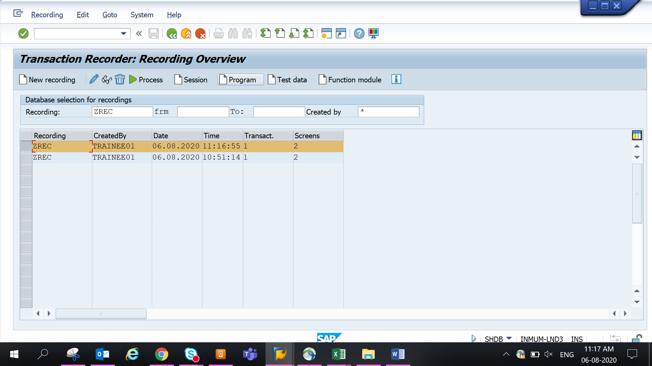

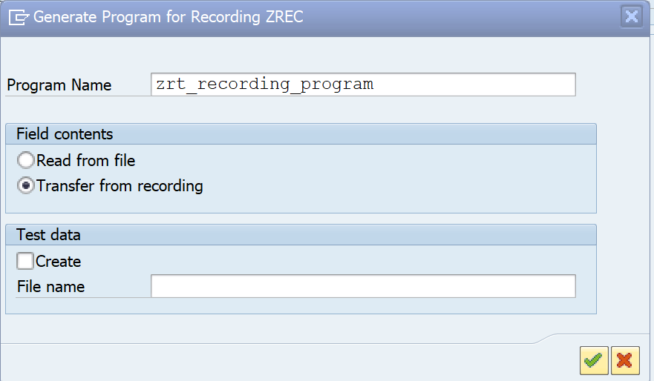

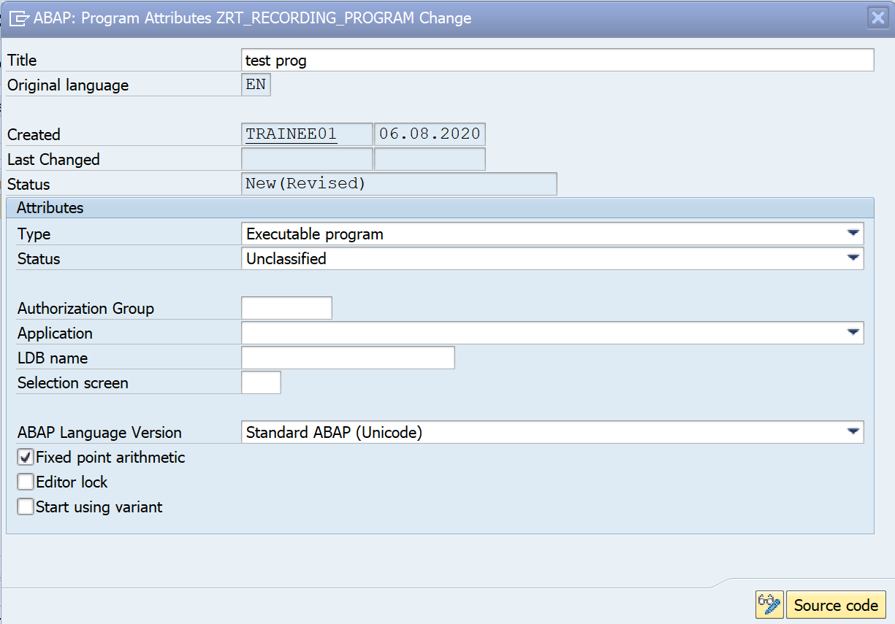

Save the program in package and view it in SE38.

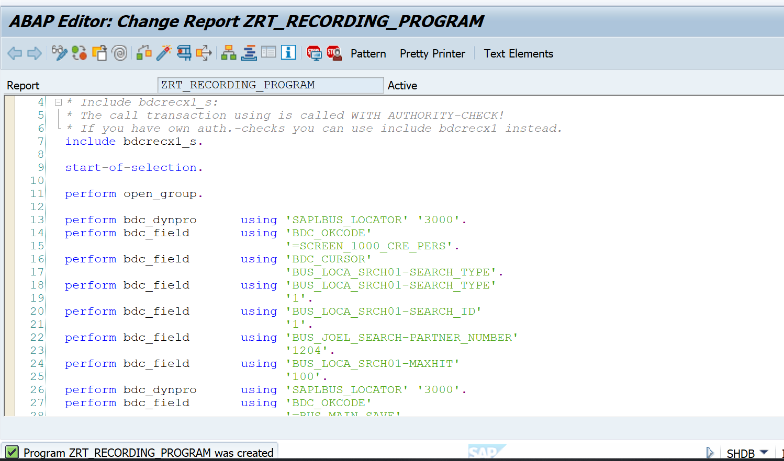

1. Execute the program

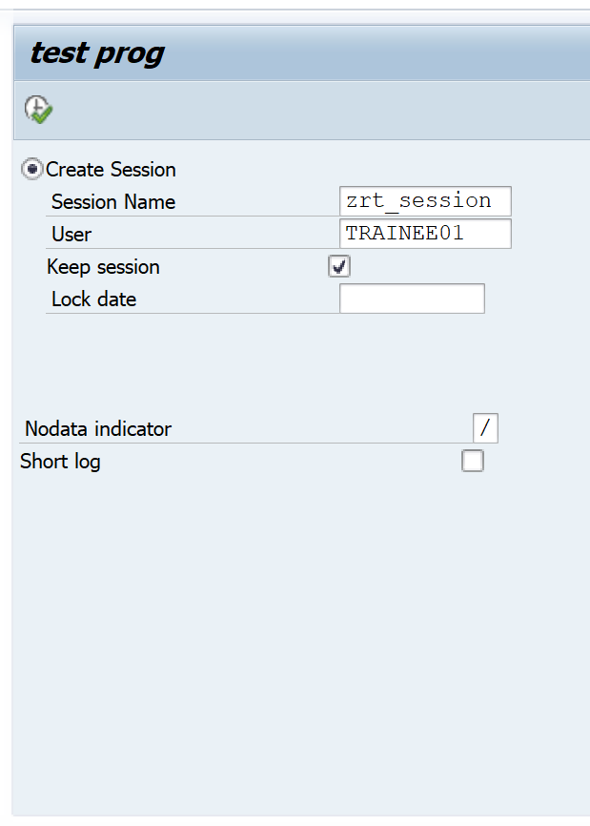

6)o/p of program is as below

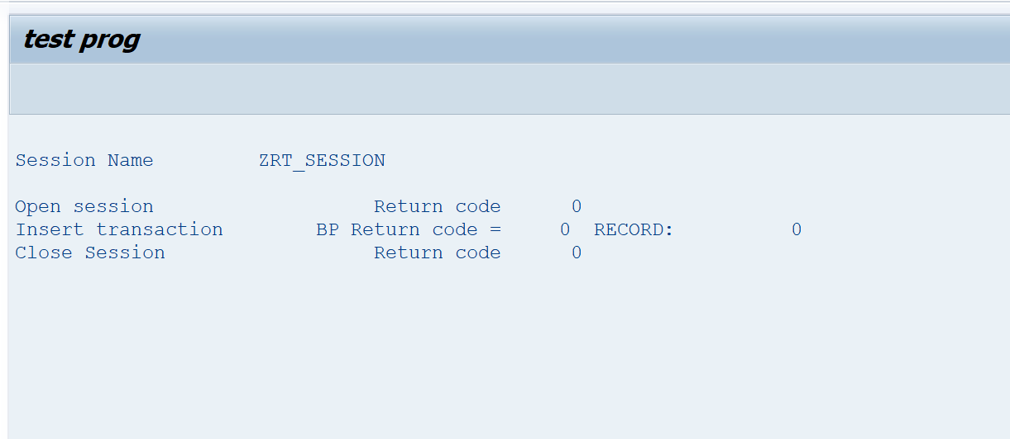Go to table BUT00. Enter the Business Partner Number.check if BP is created.